PARTS LIST- Cut lengths

A- Nylon tube .250 ID x .375 OD
Bottoms- bass 12 3/8”
tenors 2@ 9 3/8” 18 3/4"
Blow pipe 9”
40”
B- Nylon tube .375 ID x .500 OD
Bass middle 7 1/2”
Bottom & spacers 8@ 2” 16”
23 1/2”
C- Nylon tube .500 ID x .562 OD
Bass middle spacers 2@ 2” 4”
D- Nylon tube .562 ID x .625 OD
Tops- bass 7”
tenors 2@ 4” 8”
Bass middle 7 1/2”
Bottoms- bass 13”
tenors 2@10” 20”
55 1/2”
E- PVC pipe .800 ID (sold as 3/4 ID)
Tops- bass 12”
tenors 2@ 9” 18”
Bass middle 7”
Bottoms- bass 7”
tenors 2@ 4” 8”
Stocks - bass 7 1/2”
tenors 2@ 5 1/2” 11”
blowpipe, chanter 2@3 1/2” 7”
77 1/2”
F- clear plastic hose .375 OD

PLUS-
3/4” to 1” reduction brass fittings (3)
3/8” metal washers (3)
Electrical tape
Plastic cement

TOOLS-
Pipe cutter
Calipers
Razor blade
Round file

The Great
Highland Bagpipe

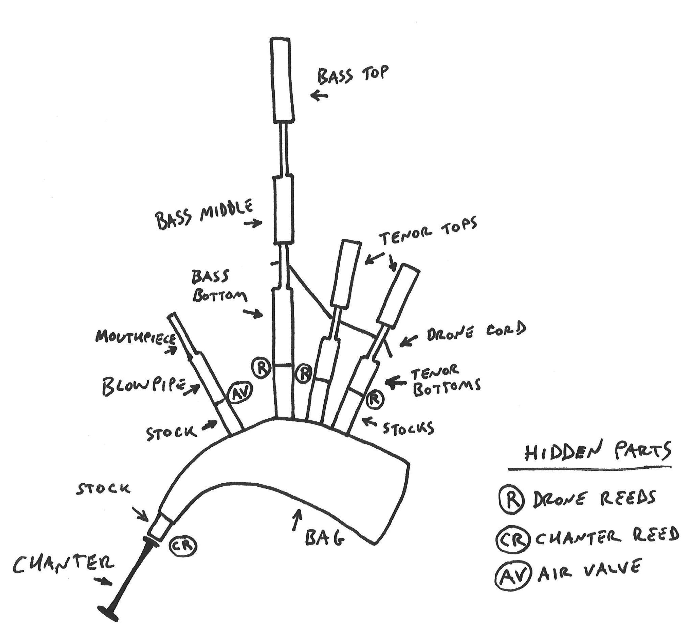

How to Make a Bass Middle

This is the hardest part to make when I make a set of composite Great Highland pipes so I always make this part first to get it out of the way. It can take days to make this part with brass tubing and then shaping it to look like something. But you make this part out five pieces of PVC and some electrical tape in about an hour.

Needed-
One B nylon tube @ 7 1/2”
One D nylon tube @ 7 1/2”
Two C nylon 2” spacers
One E PVC pipe @ 7”
Hot glue gun

Slide a C spacer on one end of the B tube and slide the D tube over it from the other end. Jam the second spacer in between the other ends of the tubes.

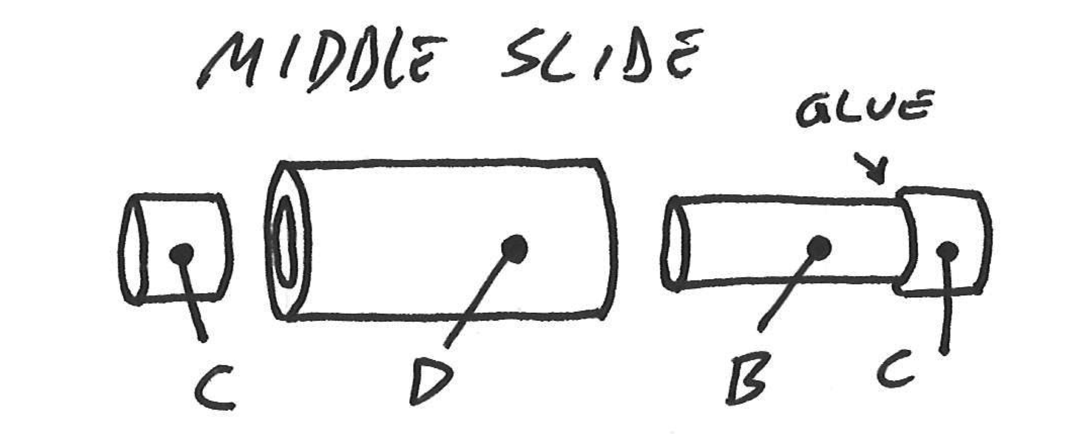

Measure the interior of the E pipe and wrap two bands of electrical tape on one end of the slide, one on the end 2 1/2” up. Now slide the E pipe on until it’s snug and covers the tape, leaving 5” of the slide exposed. Add a nice bead of glue at the base of the slide and top of the PVC pipe.

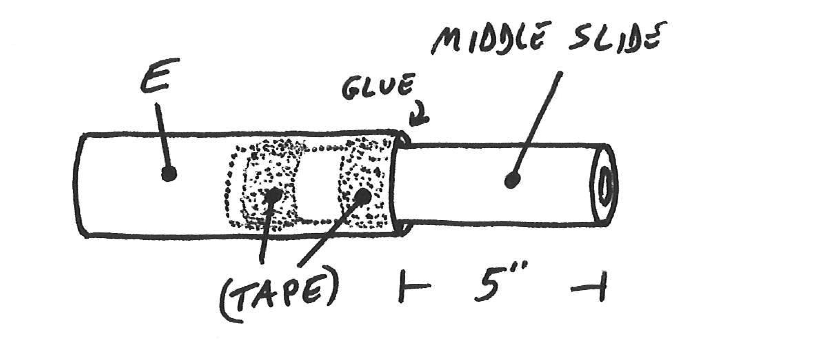
How to Make a Drone Bottom

Needed-
One A nylon tube @ 12 3/8”
Two A nylon tubes @ 9 3/8”
Six B nylon spacers @ 2”
One D nylon tube @13”
Two D nylon tubes @ 10”
One E PVC pipe @ 7”
Two E PVC pipes @ 4”

Slide a B spacer on each end of the A tubes. Adjust so the spacers are flush with one side of the A tube and overhang by about 5/8” on the other. Give a bead of glue to the inboard edge of the spacers and let dry.

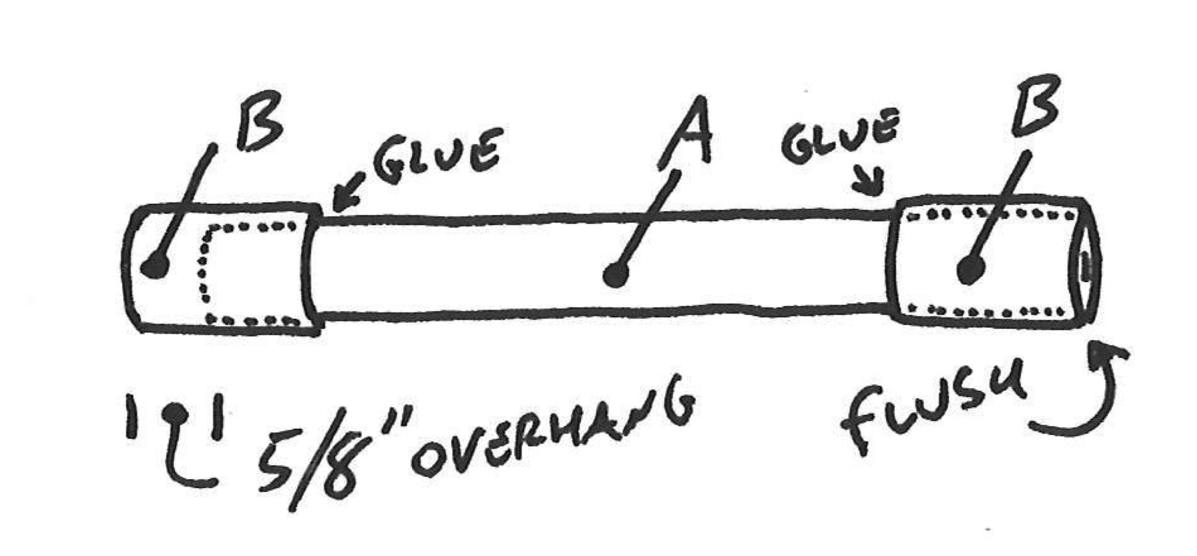

It’ll take a little practice to get the Tape Wrapping down, but it’s not that hard. Make sure the inside corners of the D tube are smooth and measure the inside diameter with the calipers. The whole point of putting the tape on is to both fill the space between the spacers and the D tube, and to make it a snug fit so things don’t move around. Wrap the tape until it’s the same diameter as the inside of the D tube and then force them together. It may take a few attempts but you’ll figure it out. Now you have the slides-

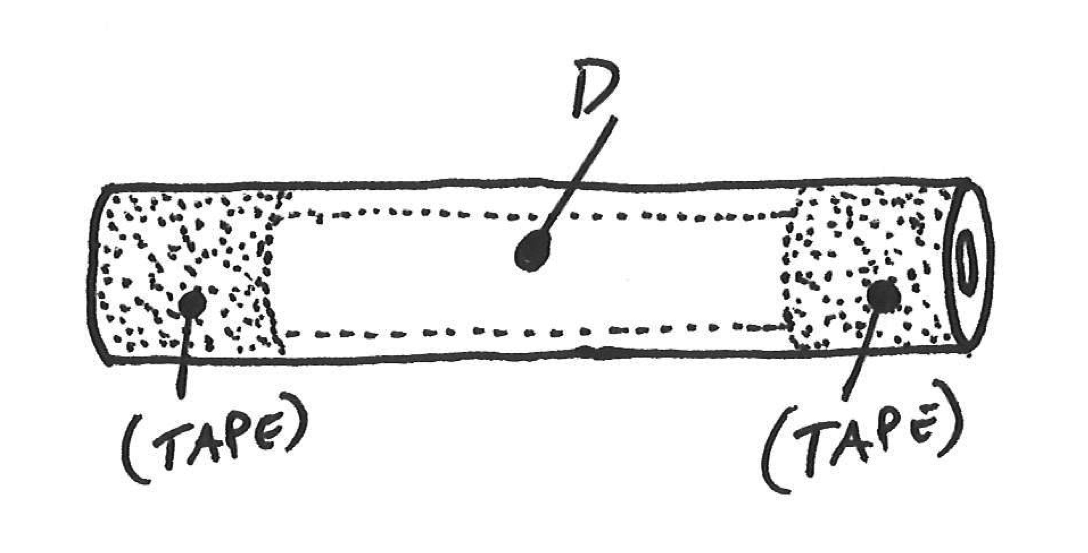

Now you’re gonna put the E PVC pipes on. The E pipes sit up about 1 1/4” from the bottom end of the slides. This is so bottoms sit about 1 1/4” into the stocks when the bagpipe is assembled. Smooth the inside edges of the E pipe with a file and wrap the slide with tape. Make sure the side with the reed seat is the side that sits out 1 1/4”.

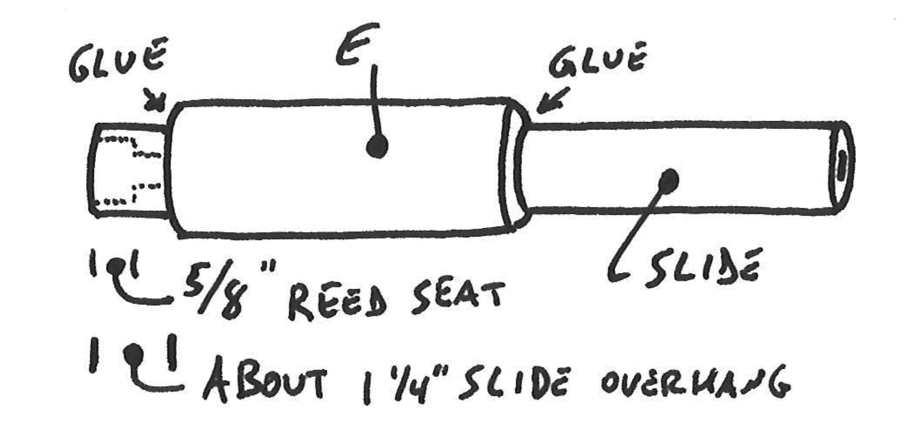

When all of the bottoms are put together give them beads of glue between the PVC and the slides.

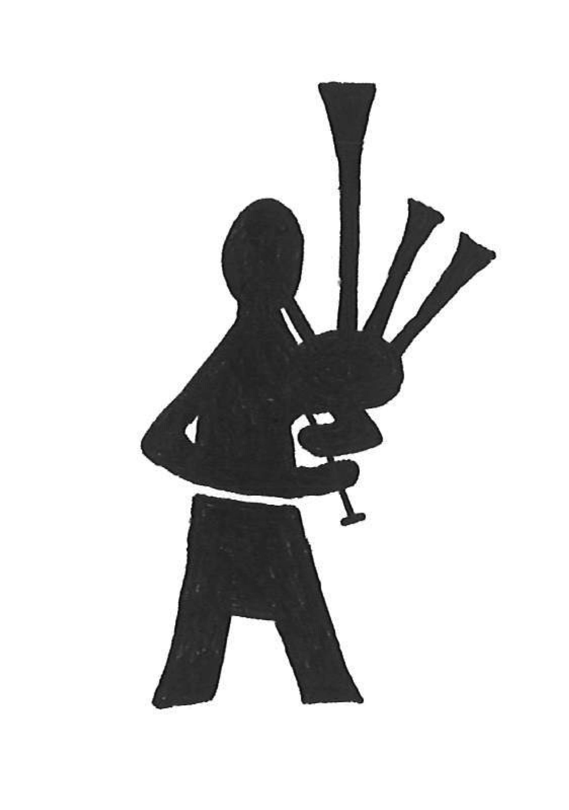
How to Make a Drone Top

Needed-
One D nylon tube @ 7”
Two D nylon tubes @ 4”
One E PVC pipe @ 12”
Two E PVC pipes @ 9”
Three 3/4” to 1/2” brass reduction fittings
Three 3/8” metal washers

Put the brass reduction fittings on one end of each of the three D tubes and secure them with glue and a couple wraps of tape. Now add enough tape to the D tube on both ends so that it fits snugly inside the E pipe. The large D goes inside the large E, and the two smaller Ds go inside the two smaller Es, but you probably got that.

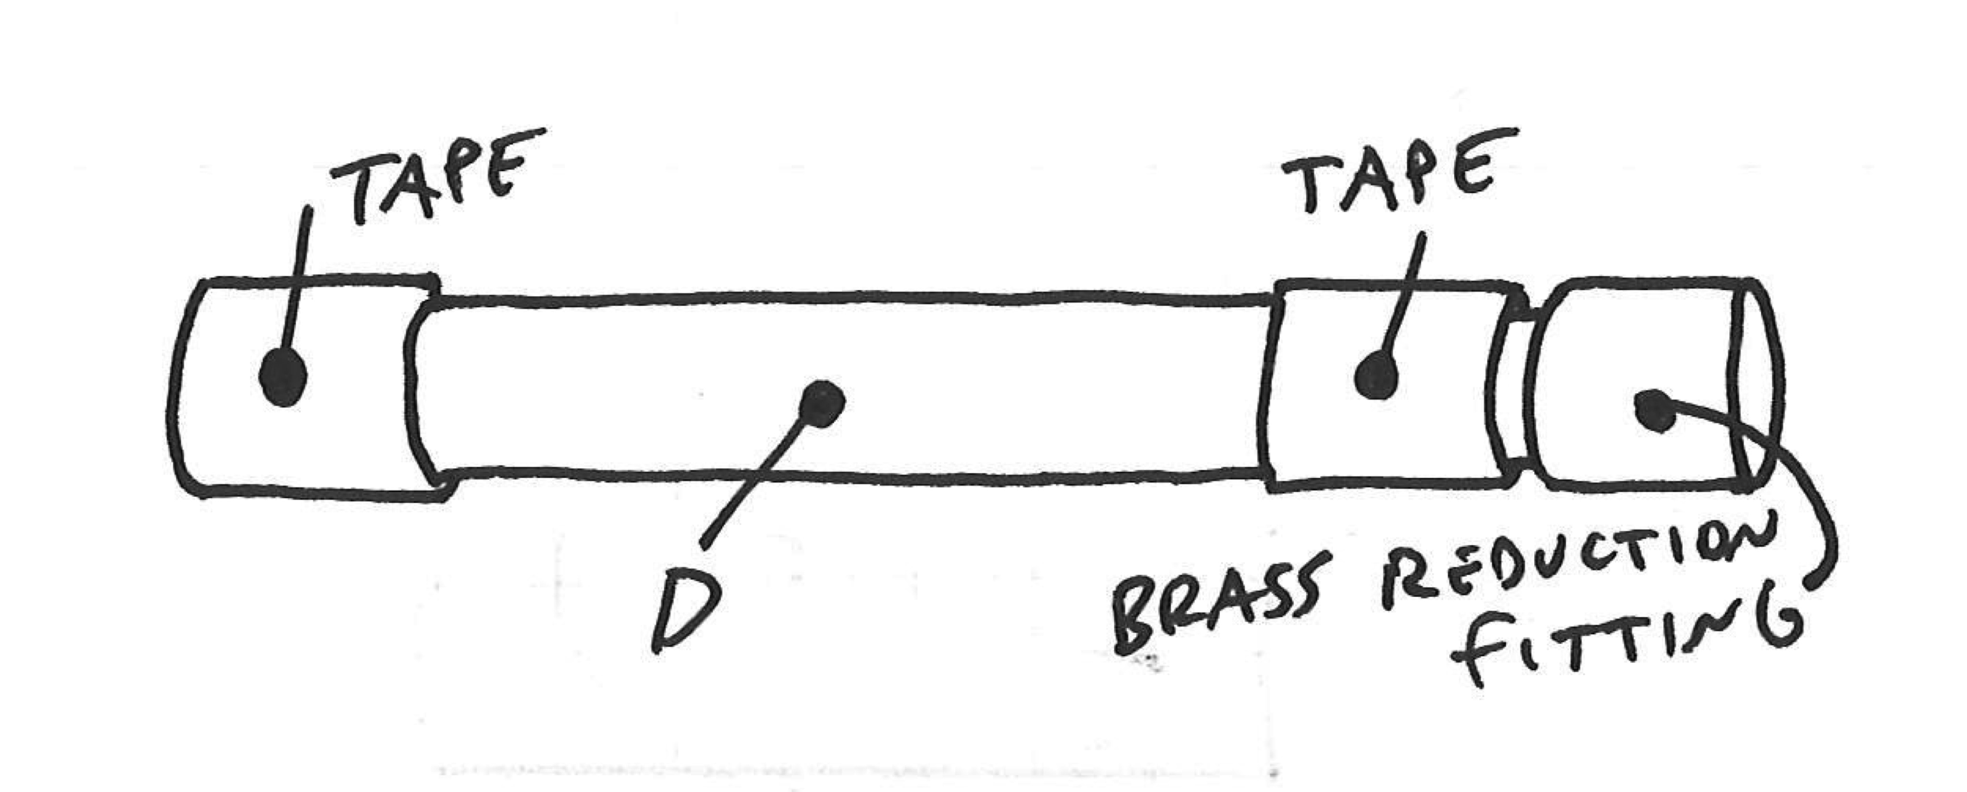

Glue the brass to the PVC. Now make yourself a quick little Cap Aligner to ensure that you put the metal cap on so that it is centered with the inner D tube. Do this with some tubing and tape. Slide the washer onto the brass and let it sit until the glue has set.

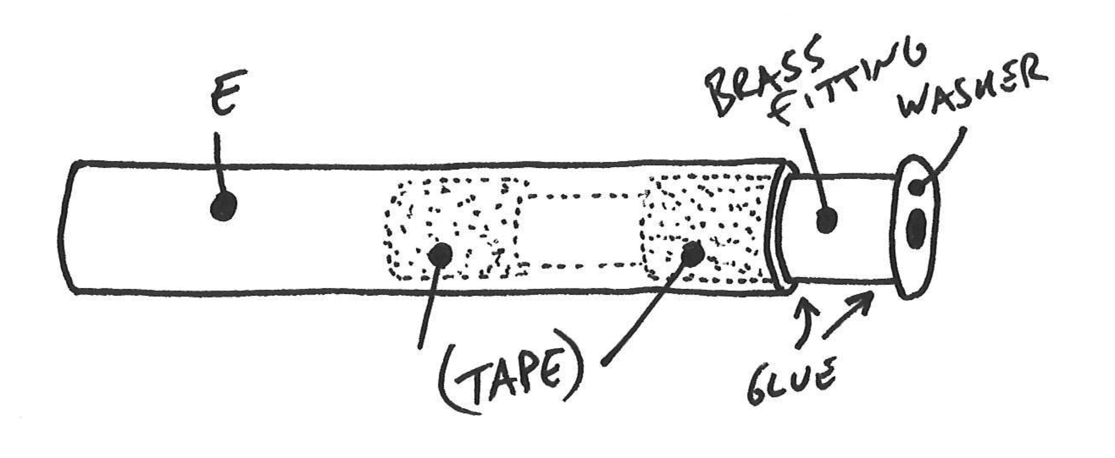

How to Make a Blowpipe

Needed-
One A nylon tube @ 9”
One C nylon tube @ 8”
Two B nylon spacers @ 2”
One E PVC pipe @ 3 1/2”
One F hose @ 4”

Put the A and C together, leaving one inch of the A sitting out of one end of the C. Next fix the PVC on the flush end but 1 1/4” up like you did with the bottoms. Add some glue and put the hose on the top.

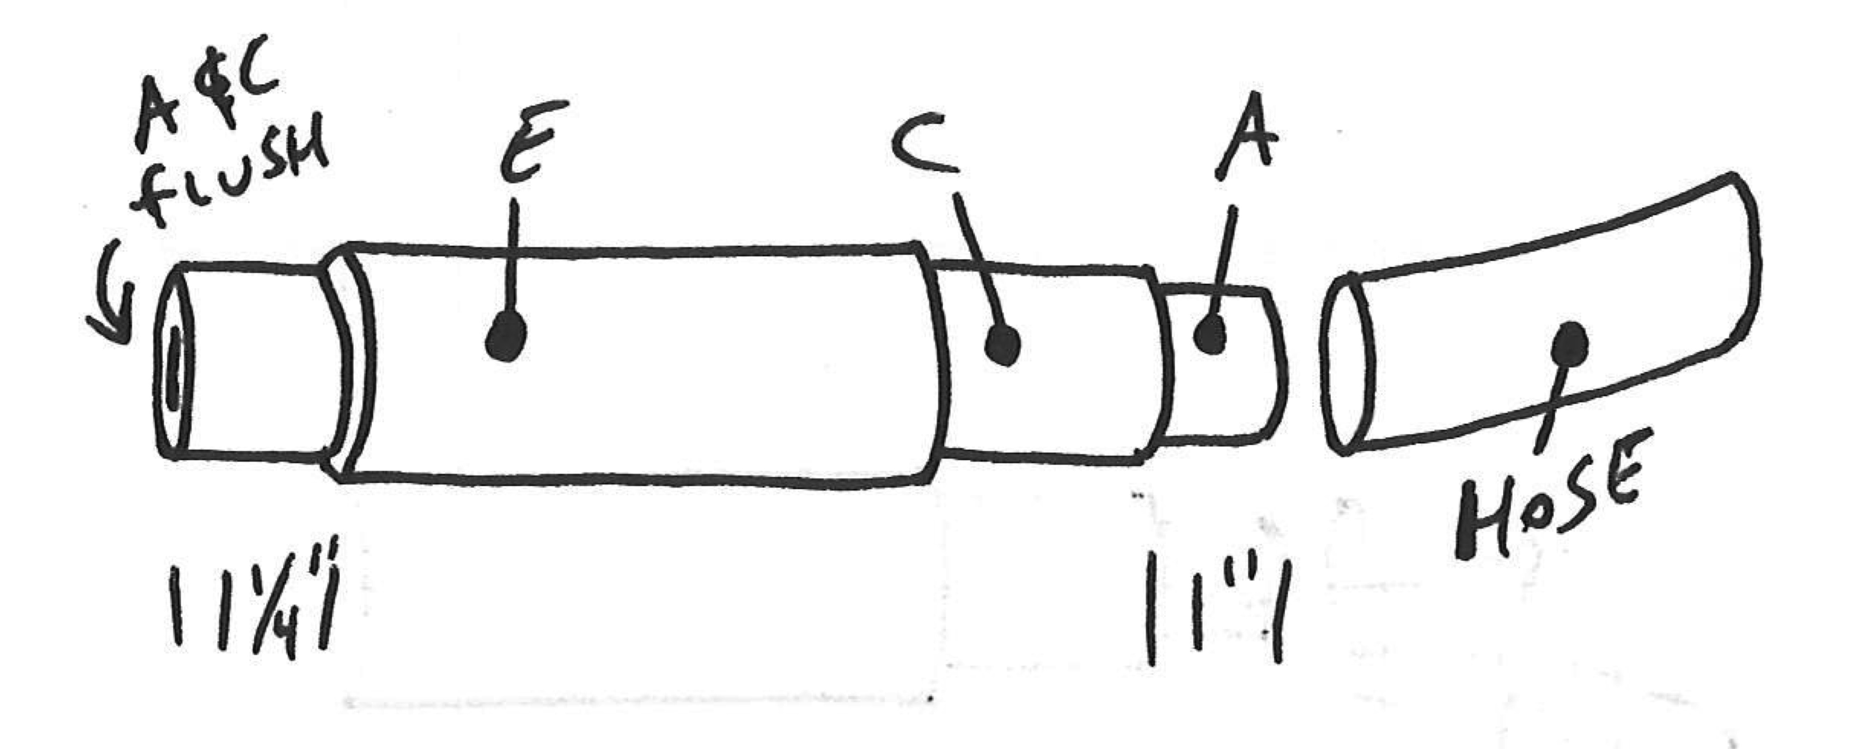

You’ll need a flap on the bottom of the blowpipe to keep the air in the bag while you take breaths. You can buy one cheap enough when you get the other bagpipe supplies.

Assemble-
Once all of your parts are made, get a large elk skin bag, reeds and a chanter from a bagpipe supply store. A tie-in kit will come with the bag that will show you how to tie the stocks into the bag.

